NAME: ALALADE PAUL

ASSIGNMENT.

1. Inside your Lesson1.html file, add the following elements:

(i) A TABLE (ii) A FORM

(Answer)

<!DOCTYPE html>

<html>

<head>

<style>

body {

background-color:

powderblue;

}

img {

width: 100%;

}

</style>

<title>ADMISSION FORM</title>

</head>

<body >

<div>

<img src="breezy.jpg" alt="rccgLogo" style="float:left;width:42px;height:42px;/>

<h1 style="font-size:60px;">R C C G</h1>

<h2 style="background-color:rgba(255, 99, 71, 0.5);">TWS Parish</h2>

<p style="color:red;">Admission! Admission!! Admission!!!</p>

<table style="width:100%">

<tr>

<th>Certificate</th>

<th>Course</th>

<th>Duration</th>

</tr>

<tr>

<td>HND</td>

<td>HTML,xHTML,XML,C++,C#</td>

<td>2Yrs</td>

</tr>

<tr>

<td>OND</td>

<td>Desktop Publishing, Website designing,.NET FrameWork</td>

<td>18months</td>

</tr>

<tr>

<td>WASSCE/NECO</td>

<td>NETWORKING,JAVA,Database</td>

<td>12months</td>

</tr>

</table>

<form action="/action_page.php">

<label for="fname">First name</label><br>

<input type="text" id="fname" name="fname" value="Paul"><br>

<label for="lname">Last name</label><br>

<input type="text" id="lname" name="lname" value="Vic"><br>

<label for="dob">D.O.B</label><br>

<input type="text" id="dob" name="dob" value="10/17/90"><br>

<label for="address">Address</label><br>

<input type="text" id="address" name="address" value="21b Crescent Avenue"><br>

<label for="cellNumber">Cell Number</label><br>

<input type="text" id="cellNumber" name="cellNumber" value="07040686372"><br><br>

<p style="font-size:160;">Gender</p>

<input type="radio" id="male" name="gender" value="male">

<label for="male">Male</label><br>

<input type="radio" id="female" name="gender" value="female">

<label for="female">Female</label><br>

<input type="radio" id="other" name="gender" value="other">

<label for="other">Other</label><br><br>

<p style="font-size:160;">Passport Class</p>

<input type="checkbox" id="passportType" name="passportType" value="ClassA">

<label for="passportType"> ClassA</label><br>

<input type="checkbox" id="passportType1" name="passportType1" value="ClassB">

<label for="passportType1"> ClassB</label><br><br>

<input type="submit" value="Submit">

<input type="checkbox" id="T&C" name="T&C" value="termsAndCondition">

<label for="T&C"> By selecting the box, you automatically accept our terms and condition.</label><br><br>

</form>

</div>

</body>

</html>

2. What does HTML stand for?

(Answer)

HTML stands for Hypertext Markup Language

3. What does the <!DOCTYPE html> signify?

(Answer)

All HMTL documents begin with the <!DOCTYPE html> declaration. This

tells the browser that this document is a .html document.

4. What is the root element of every web page?

(Answer)

The <html> element is the root element of an HTML page

5. Go to w3schools.com/html and read more about HTML. Write some short notes

on what you learn.

(Answer)

What is HTML-HTML is the standard markup language for creating Web pages.

HTML stands for HyperText Markup Language and it describes the structure of a web page.

HTML consists of series of elements and HTML tell the browser how to display the content.

An HTML element is defined by a start tag, some content, and an end tag:

Syntax for an HTML Tag- <tagname>Content goes here..</tagname>

Start tag Element content End tag

<h1> My First Heading </h1>

<p> My first paragraph </p>

<br> none no end tag

*Some HTML elements have no content e.g the <br> element.They are referred to as empty elements and do not have

an end tag..

Web Browsers

The purpose of a web browser e.g Chrome,Firefox,Edge is to read HTML documents and display them correctly.

A browser does not display the HTML tags, but uses them to determine how to display the document.

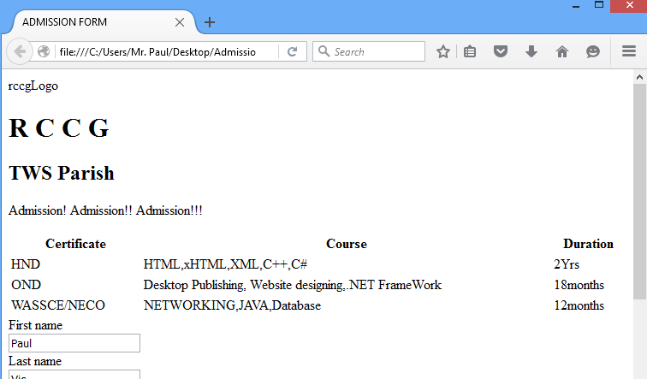

HTML Page Structure  
<!DOCTYPE html> (This tells the browser that this document is a .html document.)  
<html> (The <html> element is the root element of an HTML page)  
<head> (Opening tag for the head element)  
<title></title>(open and close tag for title element and their content are shown in the browsers title bar or in the pages tab)  
</head>(closing tag for the head element)  
<body>(opening tag for body element)  
<div></div>  
<h1></h1>   
<p></p>  
</body>(closing tag for body element)  
</html>(The closing tag for html)

They are all embedded in the body tag

HTML History  
YEAR VERSION  
1989 Tim Berners -Lee invented www  
1991 Tim Berners-Lee invented HTML  
1993 Dave Raggett drafted HTML+  
1995 HTML Working Group defined HTML 2.0  
1997 W3C Recommendation: HTML 3.2  
1999 W3C Recommendation: HTML 4.01  
2000 W3C Recommendation: XHTML 1.0  
2008 WHATWG HTML5 First Public Draft  
2012 WHATWG HTML5 Living Standard  
2014 W3C Recommendation: HTML5  
2016 W3C Candidate Recommendation: HTML 5.1  
2017 W3C Recommendation: HTML5.1 2nd Edition  
2017 W3C Recommendation: HTML5.2